**Software Process Selection and Project Plan**

**P03:Autonomous Trading Bot**

**<team member names & ids>**

|  |  |
| --- | --- |
| **Student ID** | **Name** |
| **23100011** | **Suleman Mahmood** |
| **23100198** | **Ali Asghar** |
| **23100197** | **Ahmed Tahir Shekhani** |
| **23100176** | **Syed Talal Hasan** |

**Table of Contents**

1. Introduction 3

2. Software Process Selection 4

3. Gantt Chart 5

4. Risk Management 5

4.1 Potential Risks and Mitigation Strategies 5

5. Development Environment Preparation 6

6. Deployment Platform 6

7. Who Did What? 7

8. Review checklist 7

# Introduction

A web application with an autonomous trading bot instance that will trade to generate profitable returns on stocks. The bot will be trained on the PSX data. The bot's decision will be based on the concepts of game theory, mathematical models, financial techniques, and especially artificial intelligence. The primary web app will allow the user to provide the bot's configuration, which includes, target return, risk appetite, and duration of the instance.

With recent advancements in deep learning frameworks and access to faster gpus, training complex models that can predict on time series data has opened new avenues to explore stock market trading. We plan on using models that have a memory component in them, such as LSTM (Long Short Term Memory) to make predictions and trades on the stock market.

The overall objective for the application would be to achieve the return target provided by the analyst while configuring the bot and minimize loss according to the risk factor provided. The potential users of this application would be trade analysts or managers who will use the bot to run its instances according to their requirements.  The investors will use it to view their reports of the investments. They can filter the data according to the date ranges as well.

Technical details:

The project's tech stack would be Next.js for frontend web application, Flask for backend server, and PostgreSQL for our persistent storage. The application would follow three-tier architecture with a repository pattern for the persistent layer, models, and command layer for modifying the state.

# Software Process Selection

< (1) Discuss the pros and cons of waterfall and agile (scrum) processes in your own words.

**Waterfall**:   
The pros of waterfall model include:

1. A finished product that is well-defined and predictable.
2. Clearly defined roles and responsibilities for each member from the start.
3. Detailed project planning and strict deadlines
4. After the requirement phase is finished, client engagement is not required except reviews, approvals, and status updates.
5. Since the project's whole scope was previously defined, progress can be simply tracked.

The cons include:

1. Rigidness and inflexibility following a specification.
2. Fewer chances to change course.
3. There are too many new inventions and commercial techniques by the time the final product is rolled out.
4. It takes too long for bugs/glitches to be found since testing doesn't start until the major part of the project is finished.

**Agile**:

The pros of agile model include:

1. Ability to adapt to market conditions and emerging innovations.
2. The team members have room for bringing creative solutions to new challenges.
3. Self-organizing teams and resource allocation
4. Regular updates and enhanced consumer feedback.
5. Deadline flexibility.
6. Because sprints are frequent and early in the project lifecycle, the client sees results quickly.
7. Each sprint includes the identification and resolution of bugs, allowing for modifications.

The cons include:

1. Uncertainty in the final product and delays might result from loose planning.
2. Prone to distractions and a lack of focus from one sprint to another.
3. Testing criteria that are too lenient may result in bugs.
4. No room for modification during a Sprint.
5. Additional sprints could be added if a sprint is not finished within the allotted window, which would increase both the overall time and cost.

(2) Select one of the above processes for your project development.

For the project we have focused on two major processes which include Waterfall and Agile(scrum) process while our development will follow Agile(Scrum) in particular.

(3) Justify your selection with clear reasoning. Refer to “Project Context Analysis” in the slides to get help for writing this section.>

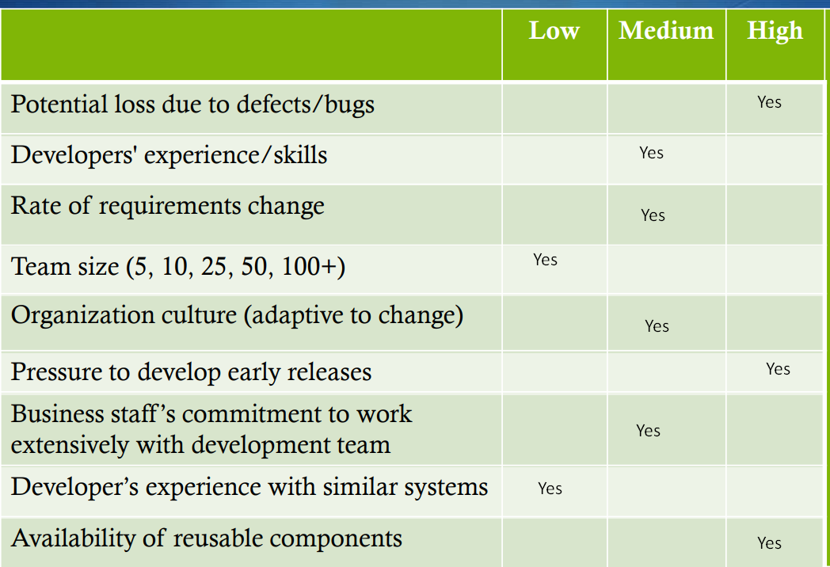

Our application is based on Financial models and techniques so we can the loss could be high if a defect and bug is left there unattended. We have developers with variety of experience low to high, in general we all are on learning phase from the project so the skills are medium in general. No large team is required as it would increase communication gap so our 5 developers can easily manage so if anyone leave we have replacement from the current 5 developers is available to cover the work of the other. We are adaptive to change and exxpects changes from client later on so it’s priority is medium. We have hard deadlines so there is a pressure of early release. Hence, Agile will help to create a working system after every sprint and scrum meetings will help us in gauging the overall performance and catchup is required.

We used the waterfall process at the start to make detailed documentation so we get clear on the requirements but for development we will follow Agile as it will help us develop the project gradually and fixing bugs timely. We are also open for creative solutions from our developers so Agile would help us catering that and since developers need to learn some other skills while developing so again Agile is the best choice for the development module of the project.

Additionally, we are using Artificial Intelligence to keep our bot updated with the market price so Agile will help us to adapt these systems into our main application as we can integrate it and make changes easily later on if required.

# Gantt Chart

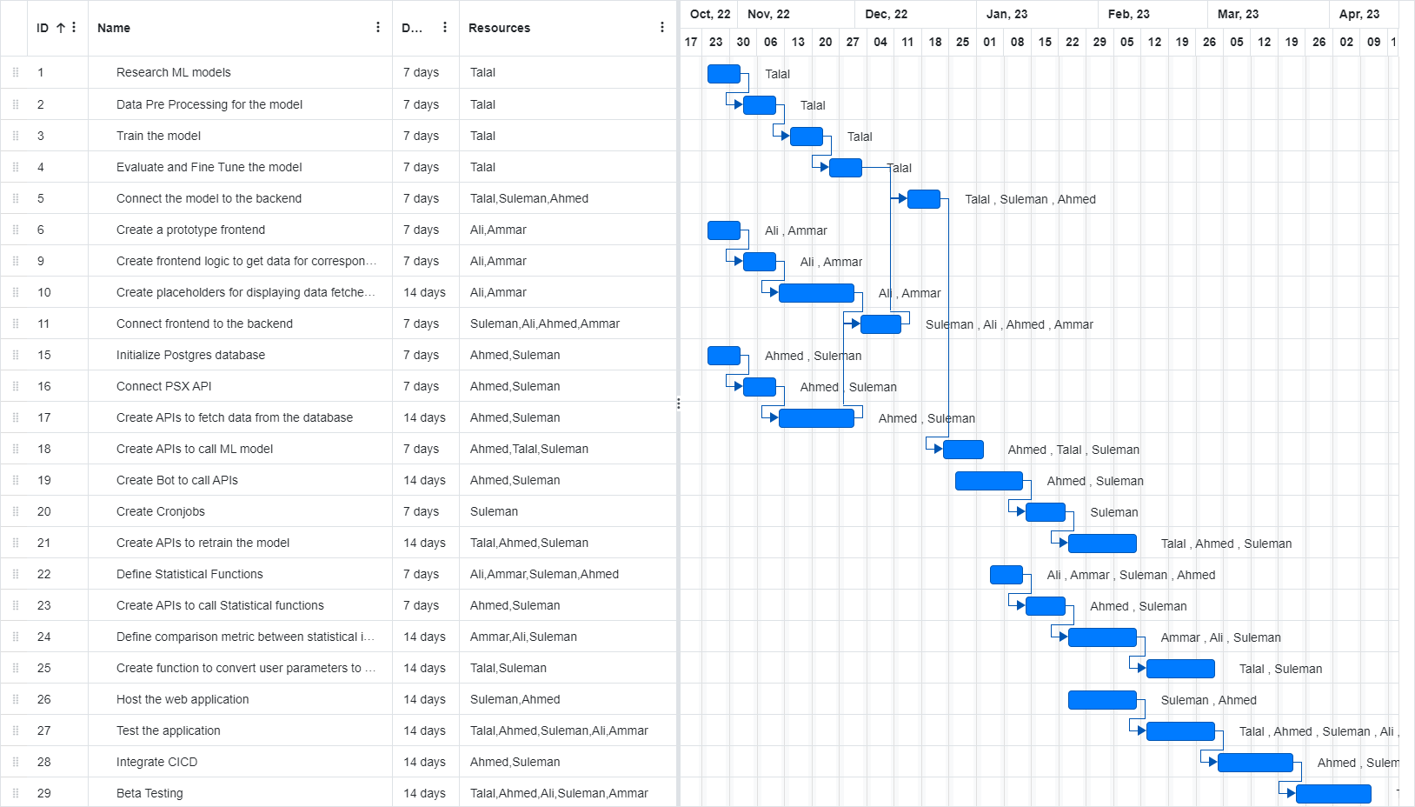

# Development Environment Preparation

**Tools and Technologies**

## Frontend

Language

* Typescript 4.8.4
* ESLint 8.25.0

JavaScript library

* Next.js 17.0.2
* React.sj 18.2.0

CSS Framework

* Tailwind CSS 3.1.8
* DaisyUI 2.31.0

API library

* Axios 1.1.2

Deployment

* Vercel

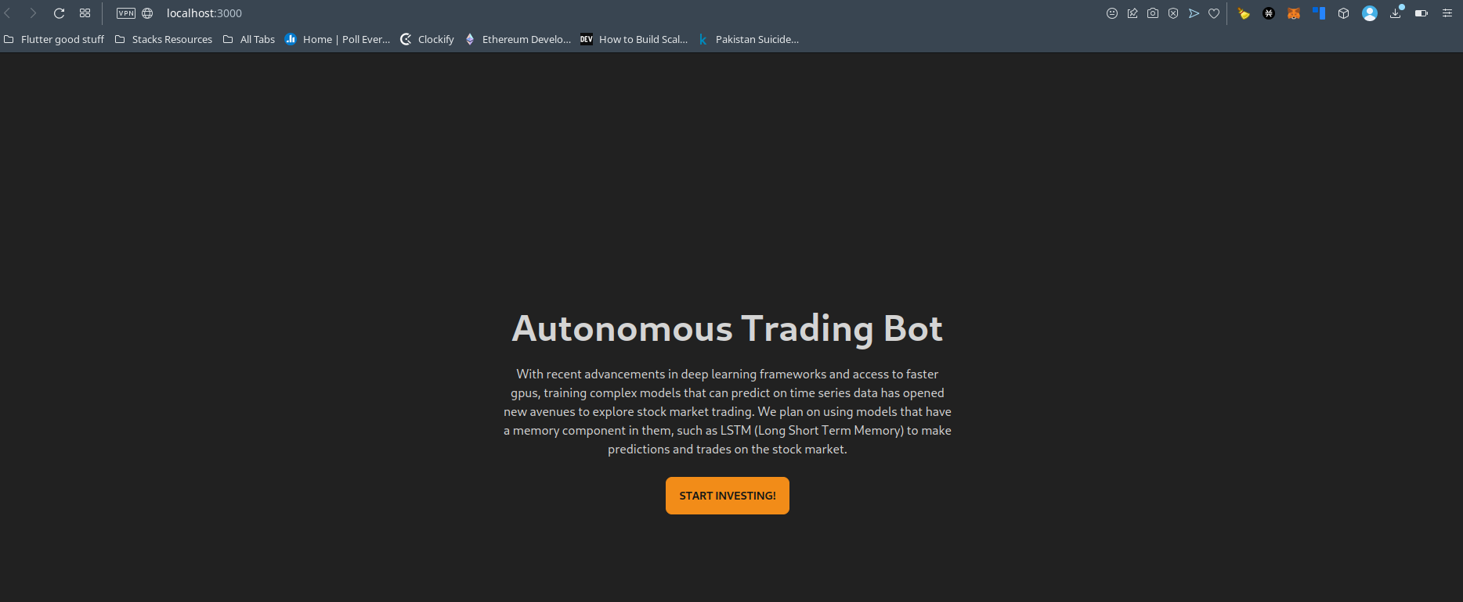

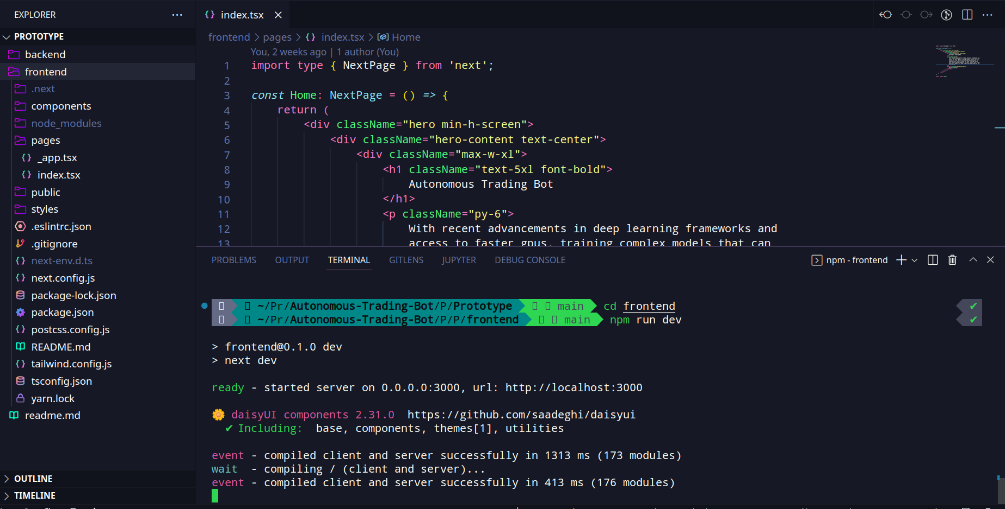

## Backend

Language

* Python 3.10.7
* PostgreSQL 15

Persistent storage

* PostgreSQL 15

Server

* Flask 2.2.2

Deployment

* Google Cloud’s App Engine flexible

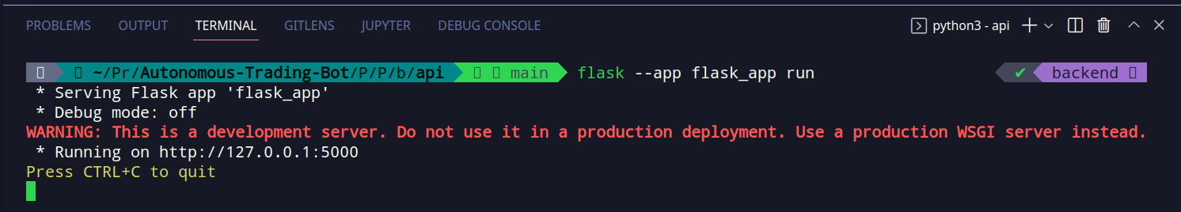

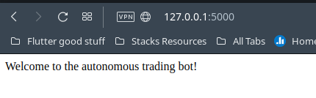

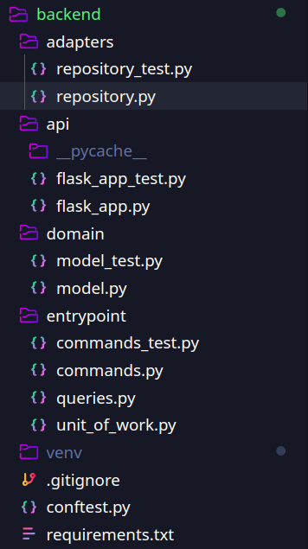

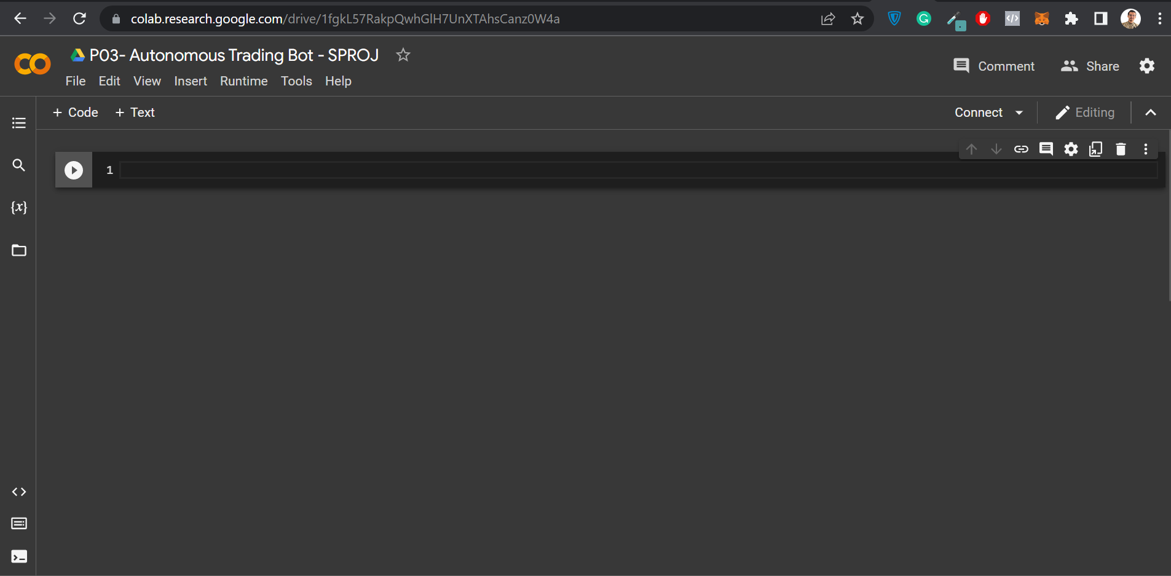

**Deep Learning Models**

Language

* Python 3.10.7

Frame work

* Pytorch and Tensorflow 1.12.1

Tool

* Google Colab

# Deployment Platform

Free hosting service: [Vercel](https://vercel.com)

We have deployed our prototype on vercel.

Prototype url: <https://autonomous-trading-bot.vercel.app/>

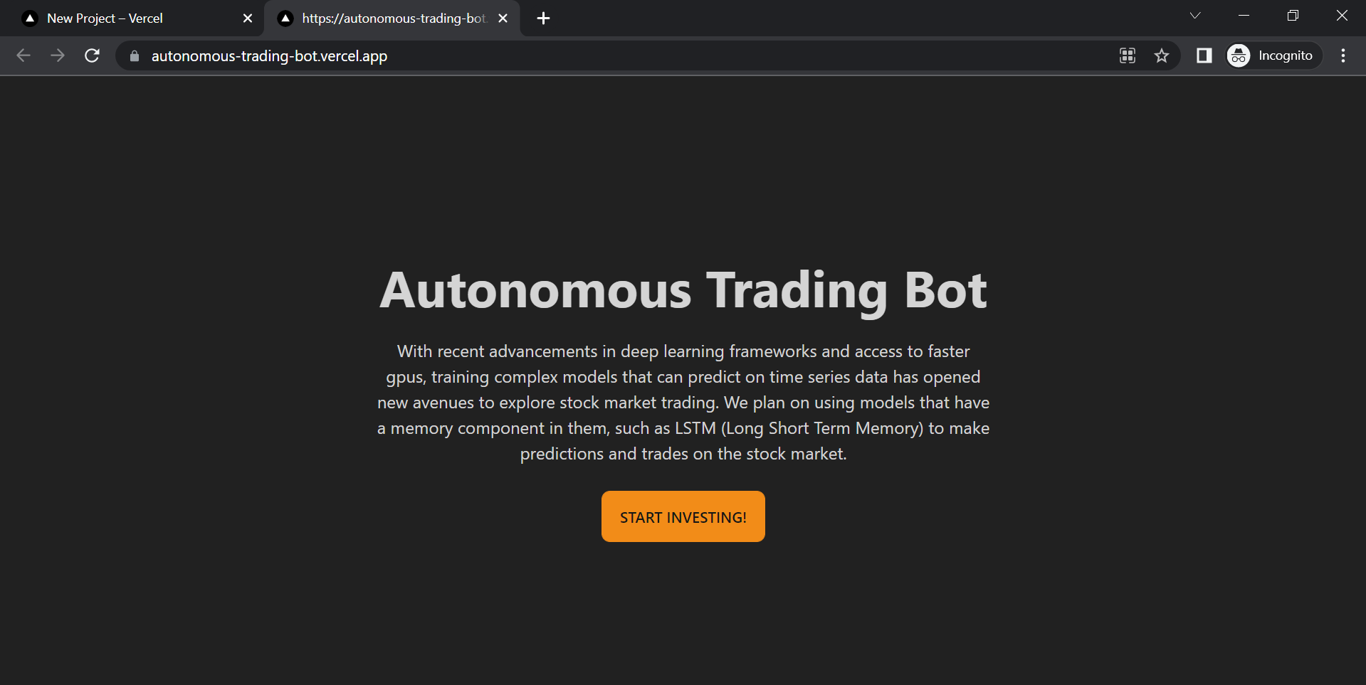

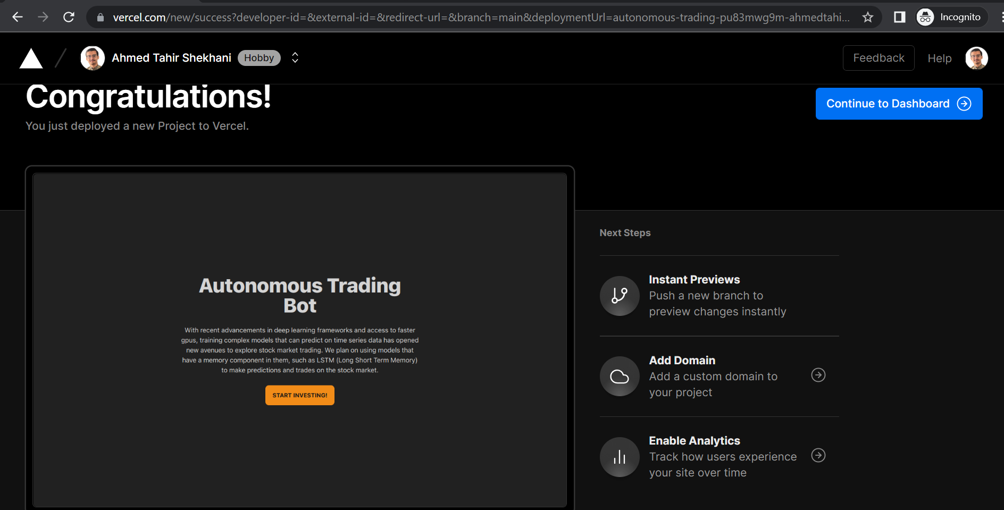

# Who Did What?

|  |  |
| --- | --- |
| **Name of the Team Member** | **Tasks done** |
| Suleman Mahmood | Development Environment Preparation (4), Deployment Platform (5) |
| Ahmed Tahir Shekhani | Section 2, Section 5 |
| Syed Talal Hassan | Gantt Chart |
| Ali Asghar | Section 2 |

# Review checklist

Before submission of this deliverable, the team must perform an internal review. Each team member will review one or more sections of the deliverable.

|  |  |
| --- | --- |
| **Section** **Title** | **Reviewer Name(s)** |
| Gantt chart (3) | Suleman Mahmood |
| Gantt Chart, Section 2, Section 4 and Section 1 | Ahmed Tahir Shekhani |
| Section 1, Section 5 | Ali Asghar |
| Section 1, Section 2 | Syed Talal Hasan |